ASP.NET Core Web API – Hands-on 3
Aim: To create a Web API that returns custom model objects and implement authorization and exception filters.
Theory:
- Custom Model Class: A custom model class represents application data using C# objects.
- HttpGet: Retrieves data from the server.
- FromBody: Reads the request body and binds it to a model object.
- Action Filter: Intercepts requests before or after an action method executes.
- Exception Filter: Handles exceptions globally and returns appropriate error responses.
Procedure:
- Create a Models folder.
- Create Employee, Department, and Skill model classes.
- Modify EmployeeController to return a list of Employee objects.
- Create a private method GetStandardEmployeeList().
- Execute the GET API using Swagger.
- Create a Custom Authorization Filter.
- Create a Custom Exception Filter.
- Test the API using Swagger.
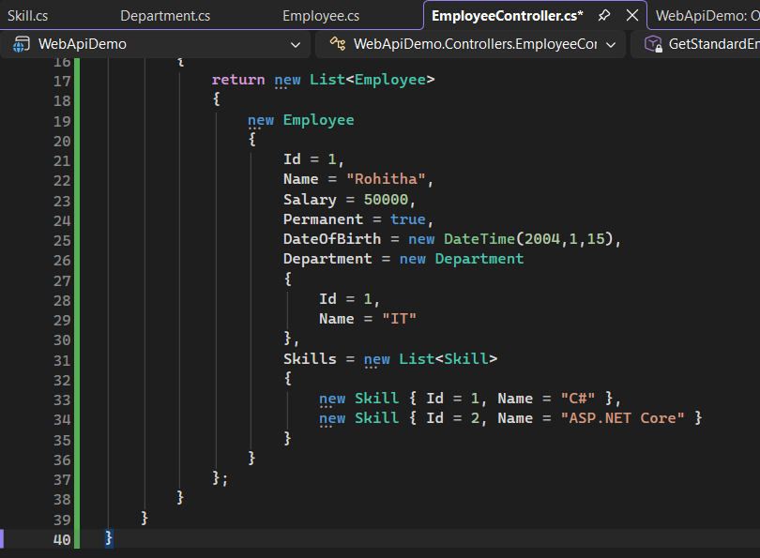
EmployeeController.cs:
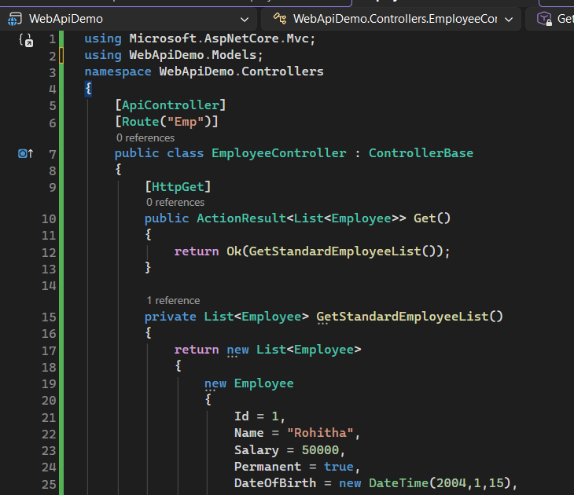
Department.cs: Skill.cs:

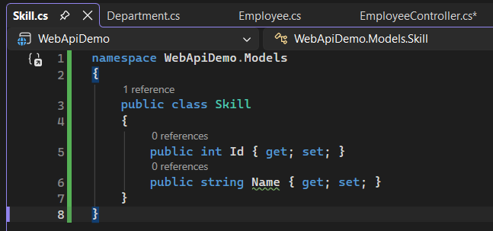
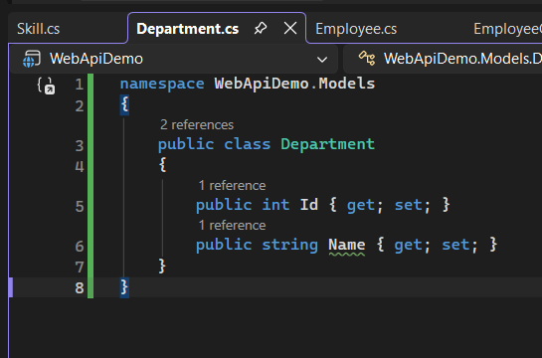

Employee.cs
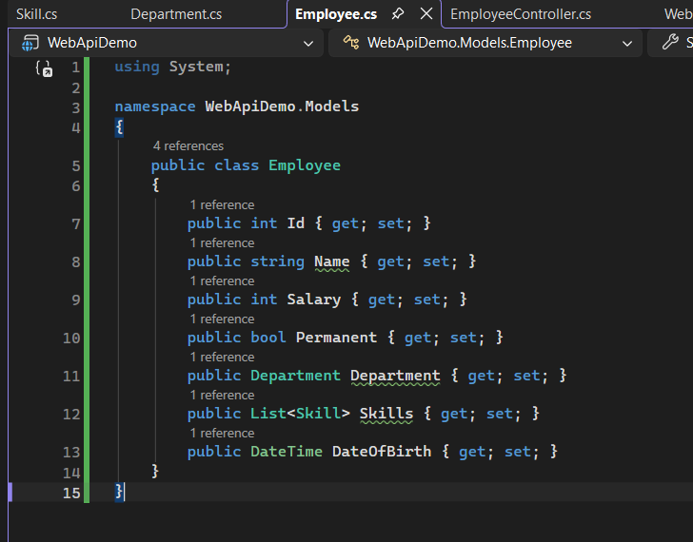

Output:
The GET API returned a list of Employee objects in JSON format.

